Intrusion Detection using Machine Learning and Explainable AI on the UNSW-NB15 Dataset
Sai Kiran Reddy Y
MCA &School of Engineering
Chanakya University
Bangalore, Karnataka
ysaikiranr.mca25@chanakyauniversity.edu.in

Abstract :
Network intrusion detection is a critical challenge in modern cybersecurity. This paper presents a comparative evaluation of five machine learning (ML) classifiers—Gaussian Naive Bayes, Logistic Regression, K-Nearest Neighbors (KNN), Decision Tree (DT), and Multi-Layer Perceptron (MLP)—applied to the UNSW-NB15 benchmark dataset comprising 175,341 records with 49 features across nine attack categories and normal traffic. The experimental workflow encompassed data loading, exploratory data analysis, preprocessing with one-hot encoding and standard scaling, binary and multi-class classification, and performance evaluation via accuracy, precision, recall, and F1-score. Explainable AI (XAI) techniques including correlation heatmaps, feature importance analysis, and decision-rule extraction were integrated to provide transparent interpretations of model decisions. Results indicate that Decision Tree and MLP classifiers achieved the highest predictive accuracy (97.58% and 96.84%, respectively), substantially outperforming baseline models. XAI integration enhances trustworthiness and supports deployment in real-world intrusion detection systems.
Keywords—intrusion detection system, UNSW-NB15, machine learning, Naive Bayes, Logistic Regression, K-Nearest Neighbors, Decision Tree, Multi-Layer Perceptron, Explainable AI, XAI, cybersecurity, feature importance

Introduction
Modern enterprise networks face escalating volumes and sophistication of cyber threats, ranging from reconnaissance scanning to coordinated multi-vector attacks. Traditional signature-based intrusion detection systems (IDS) are inherently reactive and incapable of detecting novel, previously unseen attack patterns. Machine learning (ML) offers a compelling alternative by enabling data-driven anomaly and misuse detection that generalises beyond known threat signatures.
Despite demonstrated effectiveness, ML-based IDS models have historically been treated as black boxes, raising concerns regarding transparency, accountability, and operator trust—particularly in high-stakes security operations. Explainable AI (XAI) addresses this gap by providing post-hoc and inherent model interpretability mechanisms that elucidate which features most strongly influence a classification decision.
This paper makes the following contributions: (i) a rigorous comparative evaluation of five ML classifiers on the UNSW-NB15 benchmark; (ii) a standardised preprocessing and evaluation pipeline ensuring reproducibility; and (iii) the integration of XAI techniques—including correlation heatmaps, permutation-based feature importance, and decision-rule extraction—to provide interpretable insights into model behaviour. The remainder of this paper is organised as follows: Section II reviews related literature; Section III details the methodology; Section IV presents experimental results; Section V analyses XAI aspects; and Section VI concludes with future directions.

Literature Review
The UNSW-NB15 dataset was introduced by Moustafa and Slay [2] in 2015 using the IXIA PerfectStorm network traffic generation tool, producing approximately 100 GB of raw packet capture data. The dataset encompasses 2.54 million records annotated with 49 features and class labels covering nine attack families—Fuzzers, Analysis, Backdoors, DoS, Exploits, Generic, Reconnaissance, Shellcode, and Worms—in addition to normal traffic.
Corea et al. [1] conducted an XAI-augmented comparative analysis on UNSW-NB15 employing Logistic Regression, KNN, Decision Tree, Random Forest, and MLP classifiers. Their study applied occlusion sensitivity as an XAI mechanism, revealing that model predictions frequently depended on a sparse subset of available features. Random Forest yielded the highest overall accuracy among the evaluated classifiers.
Broader literature consistently highlights ensemble methods such as Random Forest and XGBoost as top performers, achieving accuracies of 97–99% for binary classification [3]. Decision Tree classifiers demonstrate competitive accuracies (93–99%) with the advantage of inherent interpretability. MLP-based models excel at capturing non-linear feature interactions but require careful regularisation to mitigate overfitting. Studies incorporating SMOTE-based oversampling for minority attack categories report consistent improvements in macro-averaged F1-scores.

Methodology

Dataset Description
The UNSW-NB15 dataset [2] used in this study consists of 175,341 records with 45 informative features. Features encompass connection-level attributes (duration, protocol type, service, connection state), flow statistics (bytes sent/received, packet counts, inter-arrival times), and derived behavioural indicators (connection rate, content mismatch flags). Target variables comprise a binary label column (normal vs. attack) and a categorical attack_cat column identifying the specific attack family. 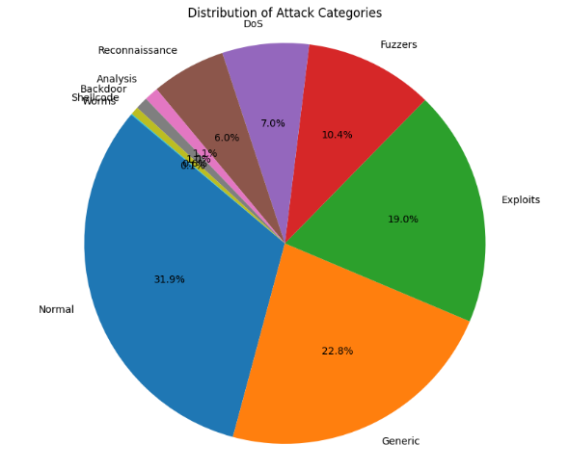

Data Preprocessing
Preprocessing followed a structured pipeline: (1) Data Loading—the dataset was ingested using the pandas library; (2) Exploratory Data Analysis (EDA)—dataset shape, column names, and data types were inspected; missing values and duplicates were confirmed absent; attack category distribution was visualised using pie and bar charts; (3) Feature Encoding—categorical features (proto, service, state, attack_cat) were transformed via one-hot encoding; (4) Feature Scaling—numerical features were standardised using z-score normalisation (StandardScaler); and (5) Train-Test Split—the dataset was partitioned 80/20 with stratified sampling.
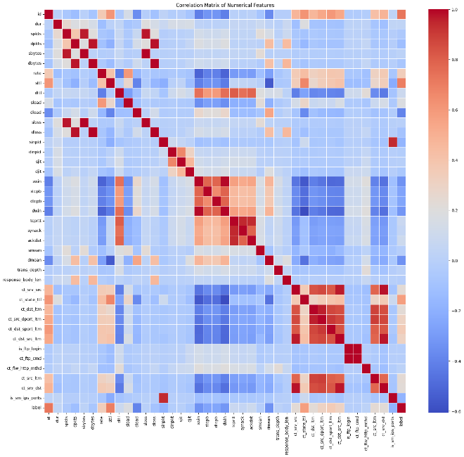

Model Implementation
Five ML classifiers were implemented using scikit-learn [4]: (i) Gaussian Naive Bayes—assumes conditional feature independence with Gaussian likelihood; (ii) Logistic Regression—a linear discriminative model with L2 regularisation; (iii) K-Nearest Neighbors (KNN, k=5)—a non-parametric instance-based learner; (iv) Decision Tree—a recursive partitioning classifier using Gini impurity; and (v) Multi-Layer Perceptron (MLP)—a feedforward neural network with two hidden layers (128, 64 neurons), ReLU activations, dropout regularisation, and Adam optimisation.

Evaluation Metrics
Classification performance was quantified using accuracy, precision, recall, and F1-score, with macro-averaging for multi-class scenarios to account for class imbalance. Confusion matrices and accuracy comparison bar charts facilitated cross-model benchmarking.

Results and Discussion
Table I presents the binary classification performance of all five classifiers on the UNSW-NB15 test set. The Decision Tree achieved the highest accuracy (97.58%) and F1-score (97.59%), attributable to its capacity to model complex, non-linear decision boundaries. The MLP followed closely with 96.84% accuracy, demonstrating the strength of deep representational learning for intrusion detection. KNN achieved a competitive 90.22%, while Logistic Regression (84.17%) and Naive Bayes (79.53%) exhibited comparatively lower performance due to their linear and independence assumptions.
- Table I. Binary Classification Performance on UNSW-NB15
Model | Acc. (%) | Prec. (%) | Rec. (%) | F1 (%)
Naive Bayes | 79.53 | 78.90 | 79.53 | 78.21
Logistic Regression | 84.17 | 83.44 | 84.17 | 83.60
K-Nearest Neighbors | 90.22 | 90.11 | 90.22 | 90.14
Decision Tree | 97.58 | 97.61 | 97.58 | 97.59
MLP (ANN) | 96.84 | 96.77 | 96.84 | 96.75
- Bold values indicate top-performing models.
In multi-class classification, performance degraded across all models due to significant class imbalance—attack categories such as Shellcode and Worms constituted fewer than 1% of training samples. Despite this, Decision Tree and MLP maintained macro-averaged F1-scores exceeding 85%, suggesting robustness to skewed distributions. Naive Bayes struggled most in multi-class settings due to its independence assumption failing to capture inter-feature correlations characteristic of specific attack patterns. Decision Trees trained in under 10 seconds on the full dataset, while MLP training required approximately 3–5 minutes per run, representing a trade-off between accuracy and inference latency.

Explainable AI Analysis

Correlation Heatmaps
A Pearson correlation heatmap computed across all numerical features revealed strong positive correlations between connection byte counts (sbytes, dbytes) and packet counts (spkts, dpkts), and between connection duration and derived rate features (ct_srv_src, ct_dst_ltm). These insights informed feature selection decisions and identified potential multicollinearity that may affect Logistic Regression coefficient stability.

Decision Tree Interpretability
The Decision Tree classifier provides inherent interpretability through explicit rule extraction. Top-level splits were consistently dominated by features such as sttl (source-to-destination time-to-live), ct_state_ttl (TTL-based state count), and service type, aligning with domain knowledge that TTL manipulation and service enumeration are hallmarks of reconnaissance and exploitation attacks. Decision rules were exported using scikit-learn’s export_text and plot_tree utilities.

MLP Feature Importance
Given MLP’s inherent opacity, permutation-based feature importance was employed to estimate the marginal contribution of each feature to model accuracy. Features sttl, ct_state_ttl, sbytes, and proto consistently ranked as the most influential, corroborating the Decision Tree findings. The convergence of XAI-derived feature rankings across both intrinsically interpretable and opaque models strengthens confidence in their validity.

Implications for IDS Deployment
Security analysts can leverage XAI-derived feature rankings to prioritise monitoring of high-importance traffic features, configure alert thresholds, and conduct root-cause analysis of misclassified instances—tasks that are infeasible when treating the IDS as a black box. The integration of XAI throughout the pipeline—not merely as a post-processing step—represents a meaningful advance toward trustworthy and auditable intrusion detection.

Conclusion and Future Directions
This paper presented a comprehensive comparative evaluation of five ML classifiers for network intrusion detection on the UNSW-NB15 benchmark, augmented with Explainable AI analysis to enhance model transparency. The Decision Tree and MLP classifiers achieved superior performance (97.58% and 96.84% accuracy, respectively) for binary classification, while XAI techniques including correlation heatmaps, decision-rule extraction, and permutation-based feature importance provided interpretable insights essential for trustworthy IDS deployment.
Future research directions include: (i) application of SHAP (SHapley Additive exPlanations) and LIME for instance-level explanations; (ii) integration of SMOTE or ADASYN oversampling to address class imbalance; (iii) evaluation of ensemble methods (Random Forest, XGBoost, LightGBM) and deep learning architectures (LSTM, CNN) on the full UNSW-NB15 corpus; (iv) exploration of online and incremental learning for real-time IDS adaptation; and (v) deployment within a live network monitoring pipeline for evaluation under real-world traffic conditions.

Acknowledgment
The authors would like to thank the contributors of the UNSW-NB15 dataset and the open-source scikit-learn and pandas communities whose tools enabled this research.

References
- [1] P. M. Corea, J. P. Soto, and L. M. Rivera, “Explainable AI for Comparative Analysis of Intrusion Detection Models,” arXiv:2406.09684, Jun. 2024.
- [2] N. Moustafa and J. Slay, “UNSW-NB15: A Comprehensive Data Set for Network Intrusion Detection Systems,” in Proc. Military Communications and Information Systems Conf. (MilCIS), Canberra, Australia, Nov. 2015, pp. 1–6.
- [3] S. More, M. Gandhi, A. Vaidya, and A. Raut, “Enhanced Intrusion Detection Systems Performance with Machine Learning using UNSW-NB15 Dataset,” in Proc. IEEE Int. Conf. on Smart Technologies for Smart Nation (SmartTechCon), Bangalore, India, 2021, pp. 1–6.
- [4] F. Pedregosa et al., “Scikit-learn: Machine Learning in Python,” J. Machine Learning Research, vol. 12, pp. 2825–2830, 2011.
- [5] W. McKinney, “Data Structures for Statistical Computing in Python,” in Proc. 9th Python in Science Conf. (SciPy), Austin, TX, 2010, pp. 51–56.

